**How long did the Edwardian era last?**

**How did people dress in Edwardian times?**

**What would it have been like to live in Edwardian Britain?**

**Who was Emmeline Pankhurst?**

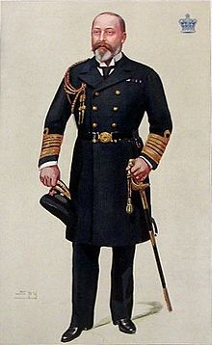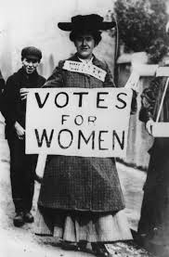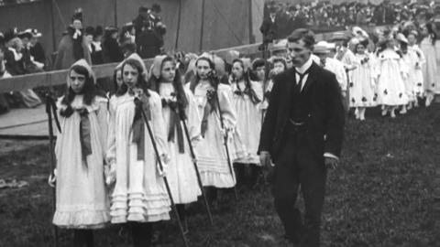

**What does suffragette mean?**

**What happened to the Titanic?**

**What were the main industries during the Edwardian period?**

**Who was the monarch?**

*Books to Read:*

* *Wind in the Willows – Kenneth Grahame*
* *The Secret Garden – Frances Hodgson Burnett*
* *Beatrix Potter Collection*
* *The Suffragettes in Pictures – Diane Atkinson*

*Things to Do:*

* *Produce a fact-file about the Monarch*
* *Draw a picture or make a model of the Titanic*
* *Answer the questions on this sheet*