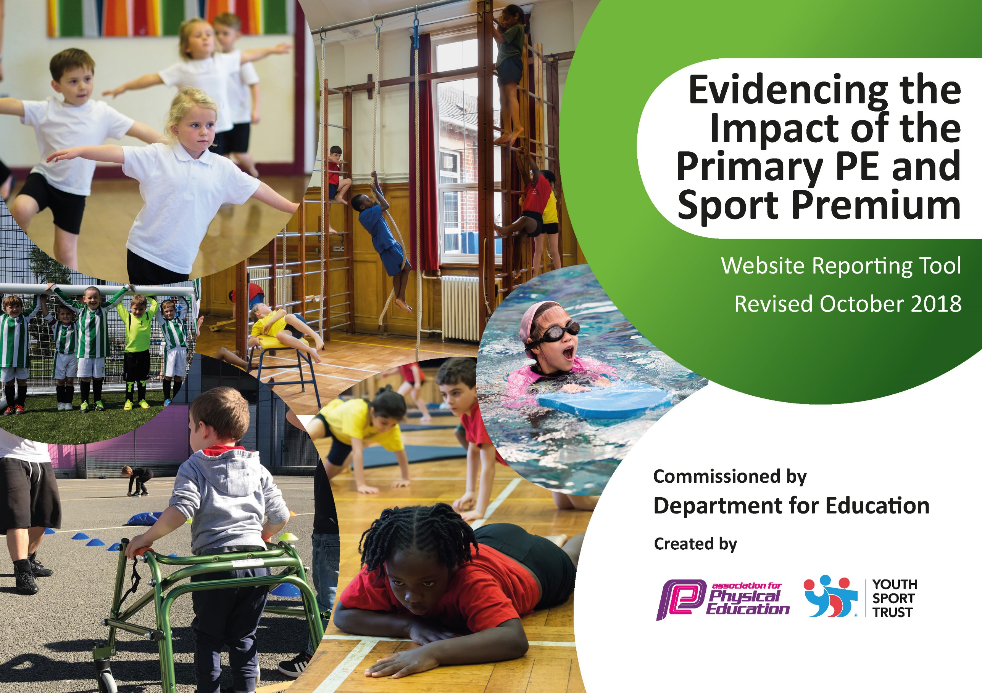
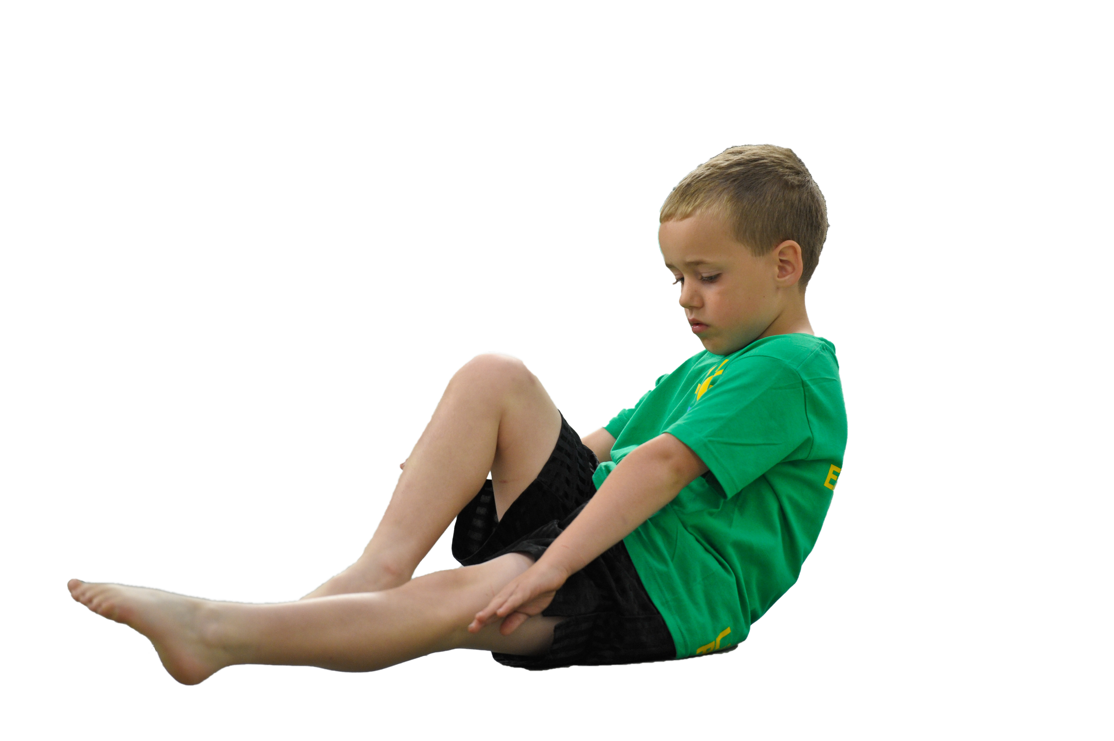
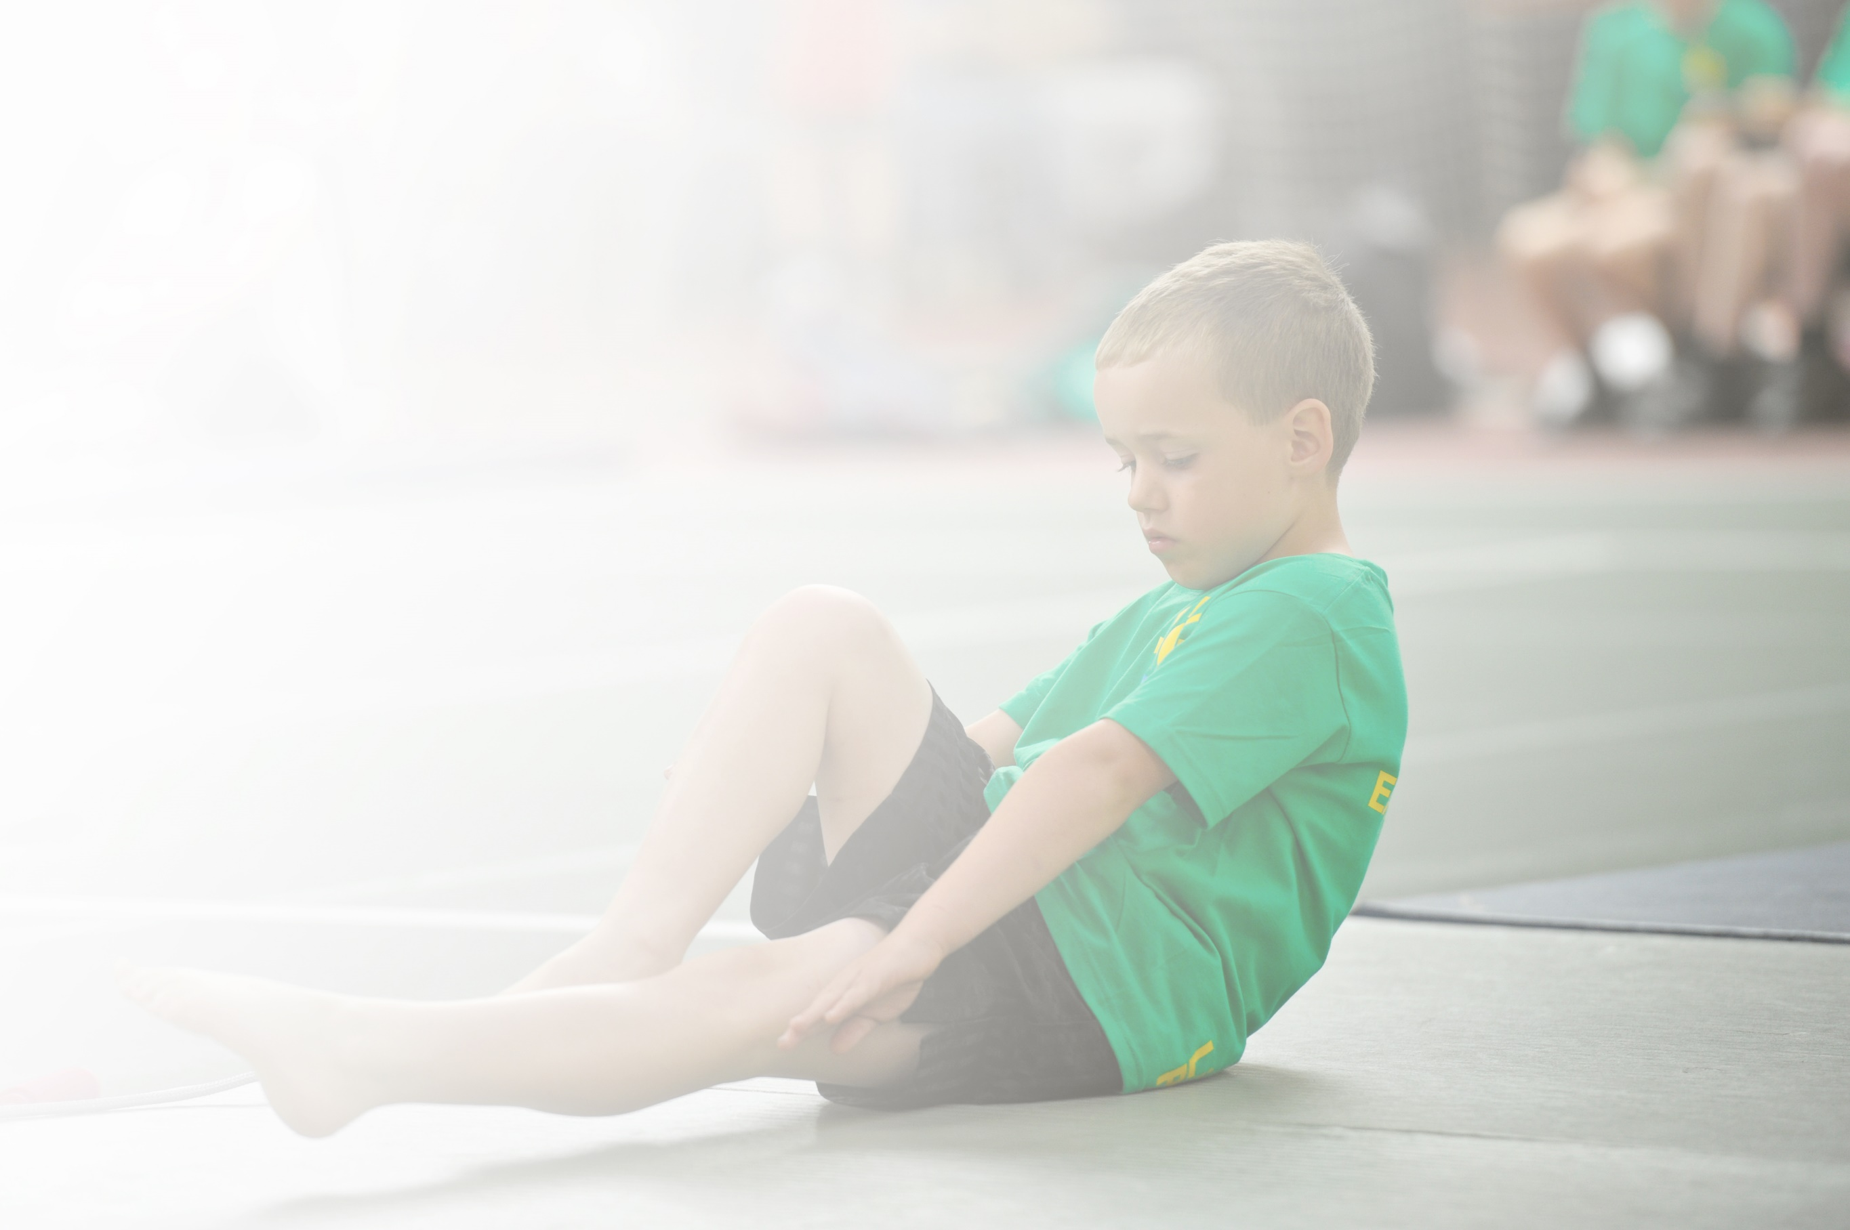
Schools must use the funding to make additional and sustainable improvements to the quality of Physical Education, Sport and Physical Activity (PESPA) they offer. This means that you should use the Primary PE and Sport Premium to:

- Develop or add to the PESPA activities that your school already offer
- Build capacity and capability within the school to ensure that improvements made now will benefit pupils joining the school in future years

Please visit gov.uk for the revised DfE guidance including the 5 key indicators across which schools should demonstrate an improvement. This document will help you to review your provision and to report
your spend. DfE encourages schools to use this template as an effective way of meeting the reporting requirements of the Primary PE and Sport Premium.

We recommend you start by reflecting on the impact of current provision and reviewing the previous
spend. Under the Ofsted Schools Inspection Framework, inspectors will assess how effectively leaders use the Primary PE and Sport Premium and measure its impact on outcomes for pupils, and how effectively governors hold them to account for this.

Schools are required to publish details of how they spend this funding as well as on the impact it has on pupils’ PE and sport participation and attainment by the end of the summer term or by 31 July 2019 at the
latest.
We recommend regularly updating the table and publishing it
on your website throughout the year, as evidence of your
ongoing review into how you are using the money to
secure maximum, sustainable impact. To see an
example of how to complete the table please
click HERE.

Support for review and reflection - considering the 5 key indicators from DfE, what development needs are a priority for your setting and your students now and why? Use the space below to reflect on previous spend, identify current need and priorities for the future.

Key achievements to date: | Areas for further improvement and baseline evidence of need:
- Increase percentage of children involved in extracurricular sport and inter and intra school tournaments.  - Re-introduced school swimming.  - Regional/area success in various sports. | - Introduce new sports or other activities to encourage more pupils to take up sport and physical activities.  - Raising the profile of sport across the school. Use P.E. and school sports as a tool to narrow the attainment gaps and to ensure at least expect progress is made.  - To continue to increase percentage of children involved in extracurricular sport and inter and intra school tournaments.

Meeting national curriculum requirements for swimming and water safety | Please complete all of the below:
What percentage of your current Year 6 cohort swim competently, confidently and proficiently over a distance of at least 25 metres?  N.B. Even though your children may swim in another year please report on their attainment on leaving  primary school. | 94%
What percentage of your current Year 6 cohort use a range of strokes effectively [for example, front crawl, backstroke and breaststroke]? | 36%
What percentage of your current Year 6 cohort perform safe self-rescue in different water-based situations? | 40%
Schools can choose to use the Primary PE and Sport Premium to provide additional provision for swimming but this must be for activity over and above the national curriculum requirements. Have you used it in this way? | Yes – support for annual local swimming gala.

Action Plan and Budget Tracking
Capture your intended annual spend against the 5 key indicators. Clarify the success criteria and evidence of impact that you intend to measure to evaluate for students today and for the future.

Academic Year: 2018/19 | Total fund allocated: £18,000 | Date Updated: 14/06/2018
Key indicator 1: The engagement of all pupils in regular physical activity – Chief Medical Officer guidelines recommend that primary school children undertake at least 30 minutes of physical activity a day in school |  |  |  | Percentage of total allocation:
 |  |  |  | %
School focus with clarity on intended impact on pupils: | Actions to achieve: | Funding allocated: | Evidence and impact: | Sustainability and suggested next steps:
- Y5 pupils learn to ride safely and develop confidence and enjoyment from cycling.  - All pupils from nursery have the opportunity to participate in a variety of sports for fun, fitness and friendship.  - All pupils are encouraged to experience a variety of physical activities to find one that sets the template for an active life.  - To ensure that all pupils learn to swim by the end of KS2 for fun, safety and fitness for life. | - Bikeability (Y5)  - Provision of extra-curricular sports clubs  - Swimming – classes Y4, Y5 and Y6.  - Swimming for targeted Y6 to achieve 25m by end of KS2 | £712.80  £200 – resources | - P.E. indoor and outdoor timetable for all classes per week (2hours of P.E.)  - Lunch time, break time and after school club timetable using the MUGA, including promoting sport holiday clubs.  Impacting upon children’s experiences and opportunities to provide a wide range of sports and activities. Promoting a healthy lifestyle.  - KS2 Swim timetable at the local swimming baths and additional provision made so that all children in Y6 can develop skills to swim 25 meters in Summer Term 2. | - To continue to provide a range/variety of sports in lessons and clubs. Look to provide to experiences each year. E.G. Yoga  - To look into organising swimming as a 2 week block booking  “intense course” to develop swimming across KS2.
Key indicator 2: The profile of PESSPA being raised across the school as a tool for whole school improvement |  |  |  | Percentage of total allocation:
 |  |  |  | %
School focus with clarity on intended impact on pupils: | Actions to achieve: | Funding allocated: | Evidence and impact: | Sustainability and suggested next steps:
- To share the creative and performance aspect of physical activity and encourage active lifestyles into the future. To raise the status and profile of this aspect of PE  - To raise the status and profile of PE both through celebrating individual or group achievement and also to encourage participation for fun and fitness.  - To highlight the variety of opportunities for activity in the local community.  - To provide a structure and criteria to ensure that a comprehensive programme of activity promoting health and fitness is in place  - To develop leadership and organisational skills in older children – play buddies. Leaders support sport events in summer term  - Increase opportunities for new sporting activities and target children less active through P.E. lessons, clubs and lunch/break activities on the MUGA.  - Range of inter and intra school competitions  - Sports day and a celebration of children’s participation.  - Achievements celebrated in class and assemblies. | - Performances  - Celebration of individual pupils or groups or teams for participation or achievement in physical pursuits in and out of school. Celebration in assemblies, school website and notice board.  - To achieve Schools Mark Bronze PE Award.  - Training and development of sporting leaders (Summer Term)  - Kick start school wellness day  - Whole school events ‘Stokesley School’s World Cup Cricket Festival’ linked to events happening out of school. Providing opportunities to celebrate events and work within a team across keys stages. Links to PSHE and how pupils resemble professional sporting athletes’ qualities in their own lives.  - Sports Day - broadening activities both individually and team events and giving purpose (links to Olympics)  - Change for life event – ensuring all children participate in sporting events for fun |  | - Inter and Intra sporting activities both competitive and non-competitive across the school.  - C4L out of school activity to encourage participation for fun and fitness.  - Recognising and awarding pupils for their achievements in sport – good team work, honesty, leadership, supporting others, etc.  - Display board  - Participation certificates for sporting activities – competitively and non-competitively.  - Links with the secondary school for events as well as other local schools.  - Hosting friendly matches with local schools, e.g. football and netball competition.  - Health wellness day  - MUGA promoting activities on lunch and beak times across KS1 and KS2. Used for clubs.  - Olympic themed sports day – individual and group events. | - To continue to listen to pupils and provide sporting opportunities that are liked.  - A timetable for a club (per week) that targets less active pupils for each year group in a club throughout the year.  - To continue to develop sporting events like Stokesley’s World Cup Cricket Festival for fun that link with what is going on in the world at that current time. E.G. Olympics, football, etc  - To continue to provide clubs, providing new opportunities to target a range of children. E.G. Yoga CPD next year - yoga clubs, meditation time, etc.

Key indicator 3: Increased confidence, knowledge and skills of all staff in teaching PE and sport |  |  |  | Percentage of total allocation:
 |  |  |  | %
School focus with clarity on intended  impact on pupils: | Actions to achieve: | Funding  allocated: | Evidence and impact: | Sustainability and suggested  next steps:
- To ensure that PE provision is improving sustainably through quality CPD for staff.  - Pupils to experience personal challenge and to develop confidence. | - Provision of training for staff working with own class alongside sports coach (James Lofthouse) to challenge pupils’ sporting skills and sporting ethos. | £2,170 - CPD | - James Lofthouse CPD football and sporting skills for all teachers across KS1 and KS2.  - Graham White – cricket coach | - To ask children for feedback and sporting activities they would like to in school so that CPD can planned to develop those areas.  - To ask teachers for areas they feel would be beneficial to promote fitness and healthy lifestyle.
Key indicator 4: Broader experience of a range of sports and activities offered to all pupils |  |  |  | Percentage of total allocation:
 |  |  |  | %
School focus with clarity on intended  impact on pupils: | Actions to achieve: | Funding  allocated: | Evidence and impact: | Sustainability and suggested  next steps:
Additional achievements:  - To challenge and develop more experienced bike riders  - To encourage awareness and interest in a wider range of physical activities | - MUGA – providing a variety of lunch time activities, after school activities and improving lesson facilities for a range of sports – hockey, basketball, netball, football, etc.  - To support teacher’s skills in sports by increasing the range of sporting opportunities and activity (MUGA)  - Clubs and break activities available as well as targeting inactive children.  - All classes take part in an outdoor educational day in Summer 2 – Cricket Day | £11,904 - MUGA | - Lunch time and break time activities provided using the MUGA across KS1 and KS2 for all.  - Clubs on the MUGA – hockey, etc  - Class timetable for the MUGA  - Promoting extra 30 minutes of exercise a day using the MUGA. | - Teachers to continue to use the MUGA for promoting a range of sports and activities.  - Continue to change clubs on the MUGA to target children.
Key indicator 5: Increased participation in competitive sport |  |  |  | Percentage of total allocation:
 |  |  |  | %
School focus with clarity on intended  impact on pupils: | Actions to achieve: | Funding  allocated: | Evidence and impact: | Sustainability and suggested  next steps:
- As many children as possible have the opportunity at least once to participate in local events, experiencing both the activity but also representing the school, collaborating as a team and enjoying being active with others.  - Competitions organised to target children including less active children.  - During all available opportunities, children will take part in inter and intra school opportunities (Lindsay Asher.) | - Participation in local tournaments – Netball, Rugby, Football, Kwik-Cricket, Athletics, Gymnastics, Cross Country, Swimming Gala, etc  - Local school friendly competitions, e.g. netball, quadkids, football, etc.  - Attend all companions ran by Lindsay Asher - organisation of cluster events/tournaments. | £2000 – L Asher  £440 – coaches to sporting events | - Inter and Intra competition  Hockey  Football  Cricket  Swimming Gala  Netball  Gymnastics  Quadkids  Curling  - Display board of teams and events taken place  - Awards in assemblies, etc  - Sports Day  - Cricket Word Cup Festival | - Continue to take part in inter and intra school events with links with the local schools.  - Continue to hold sporting events in school as well organising events linked to what is going on in the sporting world out of school.  - Continue to host events – ensure we host a range of sports target a range of pupils.

