**How would you make your mark at the South Pole?**

**What would you take in your backpack on a mission across Antarctica?**

survival

**Antarctic Exploration – Do or Die?**

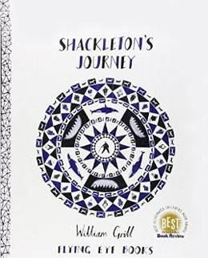

victory



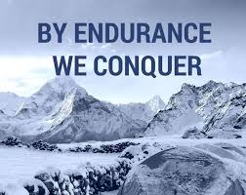

camaraderie

Elephant Island

endurance

**‘By Endurance We Conquer’**

**What would be your moto?**

**Who is your favourite crew member and why?**

*Books to Read:*

* *Who was Ernest Shackleton? – James Buckley*
* *You Wouldn’t Want to be on Shackleton’s Polar Expedition – Jen Green*
* *Dictionary - Find out the meanings of the* ***Key******Words*** *on this sheet*

*Things to Do:*

* *Design a flag to mark your arrival at the South Pole*
* *Make a logo to represent Shackleton’s polar expedition*
* *Create an acrostic poem based on the word ‘Antarctica’*
* *Explores who trek to the South Pole need at least 6,000 calories per day.*

*Plan a menu to provide the energy needed.*

* *Find out about the Antarctic in numbers (e.g. how long…. how far…*

*on which date the pole was conquered…. lowest temperature…)*

**Where is Elephant Island?**