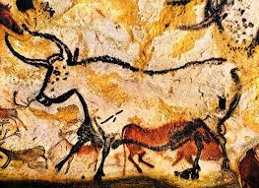

**Can you find out about the 3 periods of the stone age?**

**Homo-sapien**

**The Stone Age**

**What did Stone Age people look like?**

**Cave paintings**

**What was Stone Age food like?**

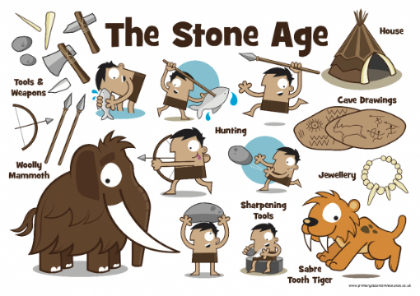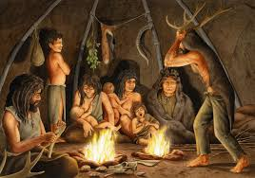

**Books/websites to explore:**

<https://kidzfeed.com/stone-age-facts-for-kids/>

<http://www.bbc.co.uk/guides/z34djxs>

Stone Age Video BBC Teach – https://m.youtube.com/watch?time_continue=5&v=-DkXHi-udxg

Stig of the Dump by Clive King

The Secrets of Stonehenge by Mick Manning & Brita Granstrom

**Things you could do:**

Go to the library and borrow a book.

Create a cave painting.

Try Stone Age counting at <https://nrich.maths.org/2472>

Go on a fossil hunt

Visit Murton Park, York to visit a stone age house

**What is it and what is it used for?**

**Flint**

**Hunter gatherers**

**Skara Brae**

**Extinct**

**Which animals are now extinct?**

**Where did Stone Age people live?**