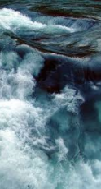
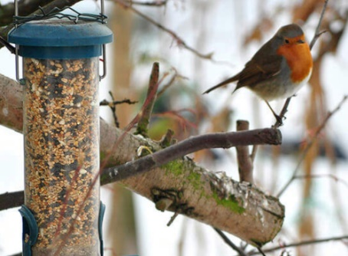
Revisit our learning, developing our stormy sea dance, music, art work and creating simple poetry.

Painting, drawing and making all kinds of models… starting with puffin pictures and masks.
Learning about birds, finding out about the different places that birds can live. Asking questions and finding out the answers.

Find out more about the seasons by observing winter. Investigating ice and snow and looking after the birds in our garden, making winter bird food.

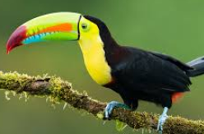
This half term we will …
Do lots of counting, practise recognising our numbers as well as learning about size and shape. We will also be learning about finding totals, adding and taking away.

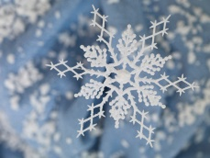

Developing our writing skills in lots of ways. Creating labels and captions for our work.

Use technology such as the ipad or photocopier to help us record and share our learning.

Learn more about feelings, thinking about what we like to do with our friends, feeling sad and what we can do to help cheer people up.

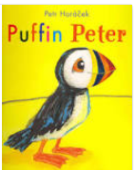
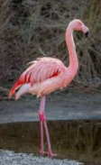
Enjoy lots of books and stories, especially Puffin Peter by Petr Horacek.

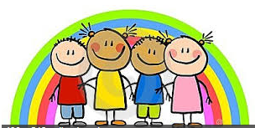

Help us at home by …
Week 1  8/1/18 | This week we are finding out about Puffins and other birds.  At home why not see if you can find out any puffin facts, or try seeing of your can spot any birds in your garden. You could draw a picture of a bird you have seen or have found out about.
Week 2  15/1/18 | This week we will be thinking about friends, what we like to do with our friends, and what makes a good friend. We will also be thinking about what makes us laugh and sharing jokes.  At home why not find your favuorite joke ( ther emust be lots left from all thoese Christmas crackers) learn it by heart or write it down to tell your friends at school, see if you can make us all laugh.
Week 3  22/1/18 | This week we will be finding out about the places that Puffin Peter and the whale visit. We will be looking at maps and making maps of journeys ( real and imagined). We will be finding out a little bit about far away places  At home why not take time to look at some maps with your child talk about what the different colours and symbols mean. You could make your own map of a journey you have been on drawing the things you see on your route or make your own imaginary map. We would love to see your maps. If your child has visited another country you could send in or email a photograph so that we can add it to our world map.
Week 4  29/1/18 | This week we are thinking about feeling sad, we will talk about what we can do to cheer up when we feel sad and be thinking of ways that we can cheer Puffin Peter up.  At home why not talk about the things that make you sad and what cheers you up. We are learning about how everyone is different and that we don’t always feel that same way about things .
Week 5  5/2/18 | This week we are retelling the whole story of Puffin Peter, making bird information books as well as our own Puffin Peter and Paul stories.  At home why not encpurage your child to tell you the story of Puffin Peter or make up your own story about the fund adventure Peter and Paul will have now they have found each other again.

We always love to hear what your child has been up to at home so please feel free to send in photos or objects for your child to talk about with their friends. You can send in photos by emailling them to l.challenger@stokesleypa.org.uk and I will print them for your child.

