English  The children will write a variety of different text types based around the chosen book for the Topic. They will consolidate using relative clauses to add extra information to sentences and punctuating speech correctly. They will continue to use a wide range of punctuation and powerful vocabulary to make writing interesting to the reader. They will then focus on moving writing forward through the use of paragraphs. | Maths  This term children will focus on fractions and decimals.  Children will be asked to find families of equivalent fractions and represent fractions as decimals. They will find the effect of dividing a 1 or 2 digit number by 10 and 100 and round decimals with one decimal place to the nearest whole number. Fractions will also be used to calculate quantities and to solve problems.
Wider Curriculum Areas
Science  Properties and changes to materials.  Children will group materials based on their properties and give reasons as to why certain materials are used for certain purposes, separate mixtures of solids, liquids and gases and explore reversible and irreversible changes.  Physical Education  PE on a Thursday afternoon will be indoor and on Tuesday PE will be outdoor.  Religious Education  This term, the children will learn about different celebrations, including Easter.  French  Children will build on their existing knowledge of the French language and will be able to respond to both written and verbal stories about animals. | Geography  The children will explore the causes and effects of climate change.  Computing  Safe, respectful and responsible use of technology will be taught. The children will learn to recognise acceptable/unacceptable behaviour and to identify a range of ways to report concerns about content and contact.  PSHCE  Keeping myself Safe and Managing Risk including online safety, domestic violence, and missing people.  Art  Children will use a range of techniques to complete their puppets.
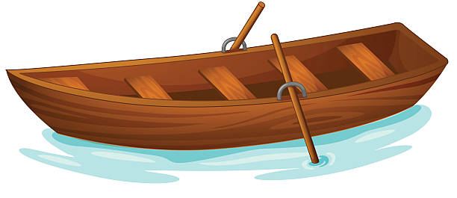
Climate Change
Spring Term 1
Year 5 PLOD

