**English**

* The children will be asked to write in a range of genres: diaries, a motivational speech, fact files, poems, ship logs, discussions, newspaper reports, job applications and CVs. These will be all based around work linked to the class novel and our topic ‘Antarctica’.
* The children will be recapping grammar, punctuation and spelling objectives from previous years.
* New GPS objectives, which will be taught in Year 6, include: more advanced verb forms, levels of formality and colons/semi-colons to separate independent clauses.
* Handwriting will be taught weekly, concentrating on letter formation, size and joins. Children will also be encouraged to make choices about handwriting styles to use in different situations.

**P.E**

* Wednesday – gymnastics (Boot camp)
* Friday – Outdoor (Mrs Routledge: tennis Miss Holden: cricket)

**Maths**

* Describe position on the full co-ordinates grid (all four quadrants).
* Draw and translate simple shapes on the coordinate plane, and reflect them in the axes.
* Identify the value of each digit in numbers given to 3 decimal places and multiply numbers by 10, 100 and 1000 giving answers up to 3 decimal places.
* Multiply one-digit numbers with up to 2 decimal places by whole numbers.
* Use written division methods by whole numbers.
* Use written division methods in cases where the answer has up to 2 decimal places.
* Solve problems which require answers to be rounded to specified degrees of accuracy.
* Solve problems involving calculations of percentages and the use of percentages for comparison.
* Recall and use equivalences between simple fractions, decimals and percentages.

**Antarctica**

**PLOD for Spring Term**

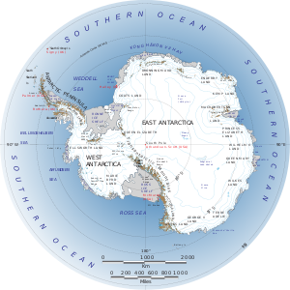

**History/Geography**

* Identify the position and significance of latitude, longitude, Equator, Northern Hemisphere, Southern Hemisphere, the Tropics of Cancer and Capricorn, Arctic and Antarctic Circle, the Prime/Greenwich Meridian and time zones (including day and night).
* Describe and understands of key aspects of physical geography (icebergs).
* To research a historical figure.

**Science Focus:**

* Recognise that living things have changed over time and that fossils provide information about living things that inhabited the Earth millions of years ago.
* Recognise that living things produce offspring of the same kind, but normally offspring vary and are not identical to their parents.
* Identify how animals and plants are adapted to suit their environment in different ways and that adaptation may lead to evolution.