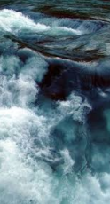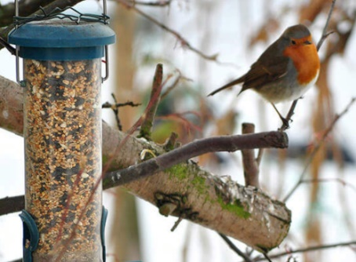

Learning about animals that live in Antarctica and creating a question and answer fact wall.

Create and develop our own penguin stories and act these out using puppets and other props.

Create penguin puppets and lots of icy, snowy winter scenes using different resources.

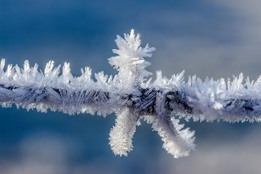

Find out more about the seasons by observing winter. Investigating ice and snow and looking after the birds in our garden, making winter bird food.



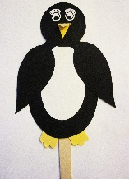

This half term we will …

Do lots of counting, practise recognising our numbers as well as learning about size, shape and capacity. We will also be learning about finding totals by adding and taking away.

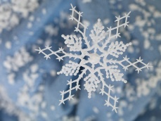

Developing our language and writing skills by describing different environments and animals. Also we will create animal fact sheets.

Use technology such as the ipad or photocopier to help us record and share our learning.

Learn more about feelings, thinking about what we like to do with our friends, feeling sad and what we can do to help cheer people up.

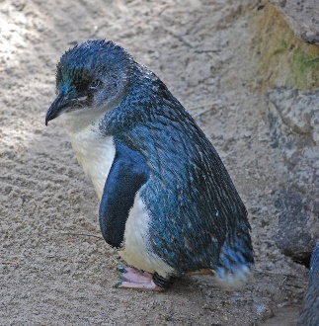

Enjoy lots of books and stories, especially Blue Penguin by Petr Horacek.

